Beyond Bitcoin: Why AI and Blockchain Are Building the Future

Blockchain is much more than cryptocurrency. It is a decentralized technology that records transactions across thousands of computers, making records extremely difficult to alter. It powers Bitcoin, Solana, NFTs, decentralized finance (DeFi), gaming, supply chains, and digital identity. What I find most interesting is that blockchains like Bitcoin and Solana are public ledgers. Anyone can view transactions using a blockchain explorer, but users are identified only by wallet addresses unless they choose to reveal themselves. That combination of transparency and privacy makes blockchain unlike any other technology.
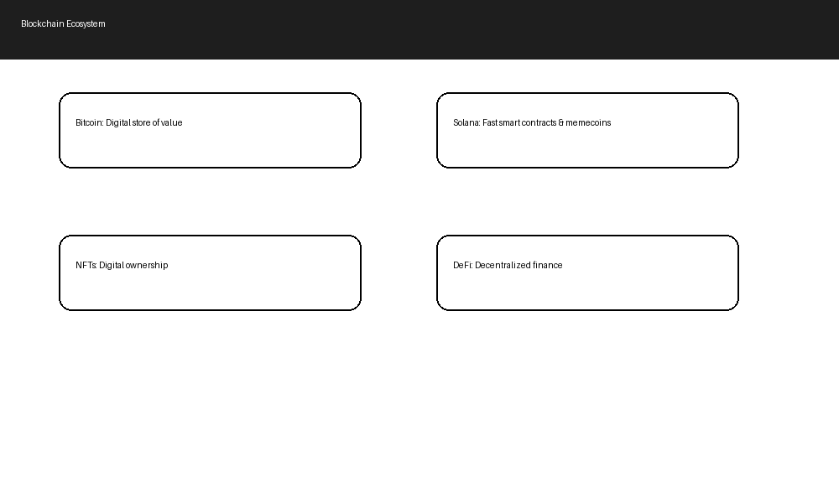
Figure 1. Major areas of today's blockchain ecosystem.

AI is making blockchain smarter and safer. Companies such as Chainalysis use machine learning to detect suspicious wallet activity, ransomware payments, and money laundering. Traders use AI to analyze on-chain data, wallet movements, and market sentiment surrounding Bitcoin, Solana, and other cryptocurrencies. Developers use AI to audit smart contracts before launch, helping prevent costly exploits. AI is also improving NFT marketplaces by identifying fake collections and recommending digital artwork.

Blockchain's transparency creates an interesting ethical challenge. Every transaction on public networks is permanently visible, yet AI can sometimes connect wallet activity to real identities, reducing privacy. AI systems can also introduce bias into fraud detection or trading recommendations if they are trained on incomplete data. Automation may replace some compliance and research jobs while creating new opportunities in AI security and blockchain development.

During the next decade, AI agents could manage crypto wallets, optimize DeFi portfolios, review smart contracts, and help secure blockchain networks. Solana's high-speed network may continue supporting gaming, tokenized assets, NFTs, and memecoin communities. Blockchain may also verify AI-generated content, helping reduce deepfakes and prove ownership of digital creations. At the same time, stronger privacy protections and thoughtful regulations will be important as adoption grows.
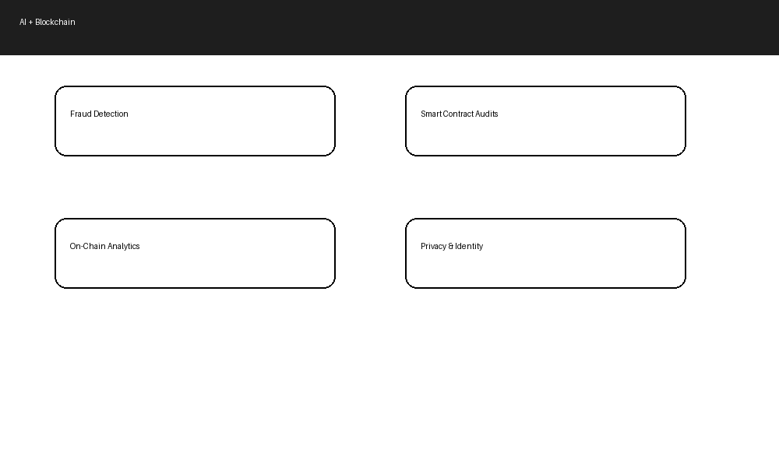
Figure 2. Ways AI and blockchain technologies complement one another.

This was honestly my favorite module because blockchain and crypto genuinely fascinate me. I enjoy following Bitcoin, the Solana ecosystem, memecoins, NFTs, and new blockchain projects because the space changes almost every day. Before researching this topic, I didn't realize how much AI was already involved in blockchain behind the scenes—from fraud detection to smart contract security and market analysis. I would absolutely love to work in this industry because it combines technology, finance, cybersecurity, and innovation. Even though scams, volatility, and privacy concerns exist, I believe blockchain has incredible long-term potential, and AI will make the technology even more useful in the future.

